UI Atoms 1.0

Contents

Overview 3

Basic Controls 3

Features 3

Layout Controls 4

AtomForm 4

AtomViewPanel 5

List Controls 5

AtomListBox 5

AtomComboBox 5

AtomNumberComboBox 5

AtomCheckBoxList 6

AtomRadioButtonList 6

Editor Controls 6

AtomTextBox 6

AtomEmailTextBox 6

AtomNumberTextBox 6

AtomIntegerTextBox 6

AtomCurrencyTextBox 6

AtomTextBoxWithRegEx 6

AtomPasswordBox 6

AtomPasswordBoxAgain 6

AtomDateEditor 6

AtomMultipleDateEditor 6

Other Controls 6

AtomButton 6

AtomFileSizeLabel 6

AtomToggleButtonBar 6

Price 6

Support 6

Professional Controls 7

Features 7

Items 7

Price 7

Support 7

Premium Controls 8

Features 8

Items 8

Price 8

Support 8

# Overview

UI Atoms 1.0 can help you reduce 70% of your code by combining various features like Form Layout, Validation, Conversion and ready to use Business controls that improves customer satisfaction by providing intuitive user interface experience.

Generic WPF and Silverlight controls offers rich customization feature but often projects turns into huge piles of code to manage and maintain.

# Basic Controls

## Features

* Rapid Business Form Development
  + Standard Form Design
  + Error Display Support
  + Form Item Customization
  + Dynamic Layout Adjustment on Label Change
* Quick Validation
* Watermarked Controls
* Simple Drag and Drop
* Ready to Use Controls
* Advanced Form Layout Control
* 70% Reduction in Code
* Rich Configurable Properties
* Easy Validation
  + Turn on Validation with Simple IsRequired Property
  + No Additional Tag
  + Error Message Property Customization
* Available for both WPF and Silverlight

## Layout Controls

### AtomForm

AtomForm is Vertical Stack Panel which can layout AtomFormItem controls automatically as shown below.

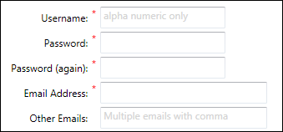

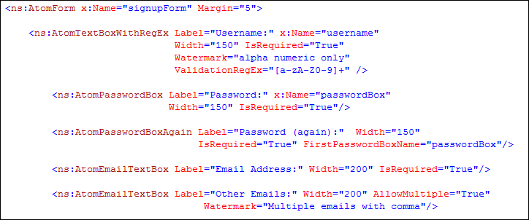

AtomForm automatically sets padding on the left of each item for Form to look as shown above. Each Atom control has Label, IsRequired, Description and Title properties. If you want to use your own control and if it does not have these properties, you can use AtomForm.Label attached properties.

Atom control supports inbuilt quick validation, which can be turned on just by specifying IsRequired property. Following is the error message displayed at time of validation. AtomButton control automatically validates everything before executing Click event handler.

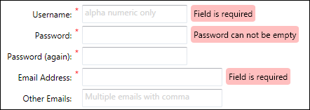

AtomFormItemContainer is Content Control which contains Header, IsRequired, Content and Description laid out automatically as shown in preview. You can customize this if you wish to. AtomForm will display a red astrix sign if IsRequired is set to true.

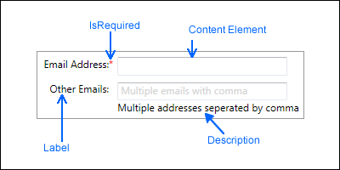

It is very easy to set form layout in minutes. Validation error messages will be displayed automatically as shown in the AtomForm example.

### AtomViewPanel

AtomViewPanel is similar to ViewStack, where it can host multiple items but only one item. You can use SelectedIndex Property to display the item.

## List Controls

All the List Controls supports inbuilt Validation.

### AtomListBox

AtomListBox is derived from ListBox and it supports AtomForm Validation. Validation is performed on SelectedIndex Property and it raises Validation error if it is -1 that is when no item is selected. You can optionally set InvalidIndices Property to raise error on other indices.

### AtomComboBox

AtomComboBox is derived from ComboBox and it supports AtomForm Validation. Validation is performed on SelectedIndex Property and it raises Validation error if it is -1 that is when no item is selected. You can optionally set InvalidIndices Property to raise error on other indices.

### AtomNumberComboBox

AtomNumberComboBox is derived from AtomComboBox and it can automatically fill the numbers from StartNumber to EndNumber and you can define the increment value.

### AtomCheckBoxList

### AtomRadioButtonList

## Editor Controls

### AtomTextBox

### AtomEmailTextBox

### AtomNumberTextBox

### AtomIntegerTextBox

### AtomCurrencyTextBox

### AtomTextBoxWithRegEx

### AtomPasswordBox

### AtomPasswordBoxAgain

### AtomDateEditor

### AtomMultipleDateEditor

## Other Controls

### AtomButton

### AtomFileSizeLabel

### AtomToggleButtonBar

## Price

## Support

# Professional Controls

## Features

## Items

## Price

## Support

# Premium Controls

## Features

## Items

## Price

## Support